**NAMA : REZA MUCHAMAD HAFIS**

**NIM :2100018227**

**KELAS : E**

TUGAS MANDIRI 1 PEMPROGRAMAN WEB

**SS Github**

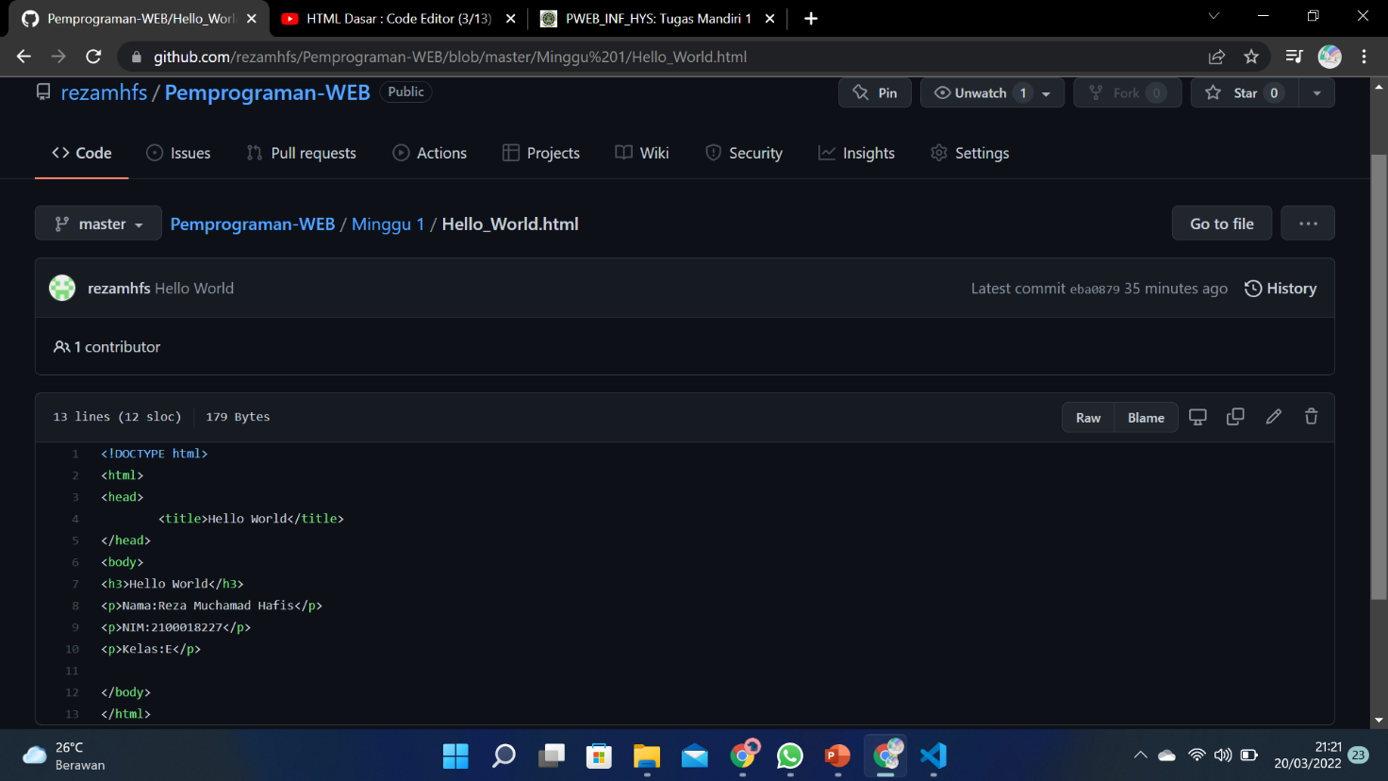

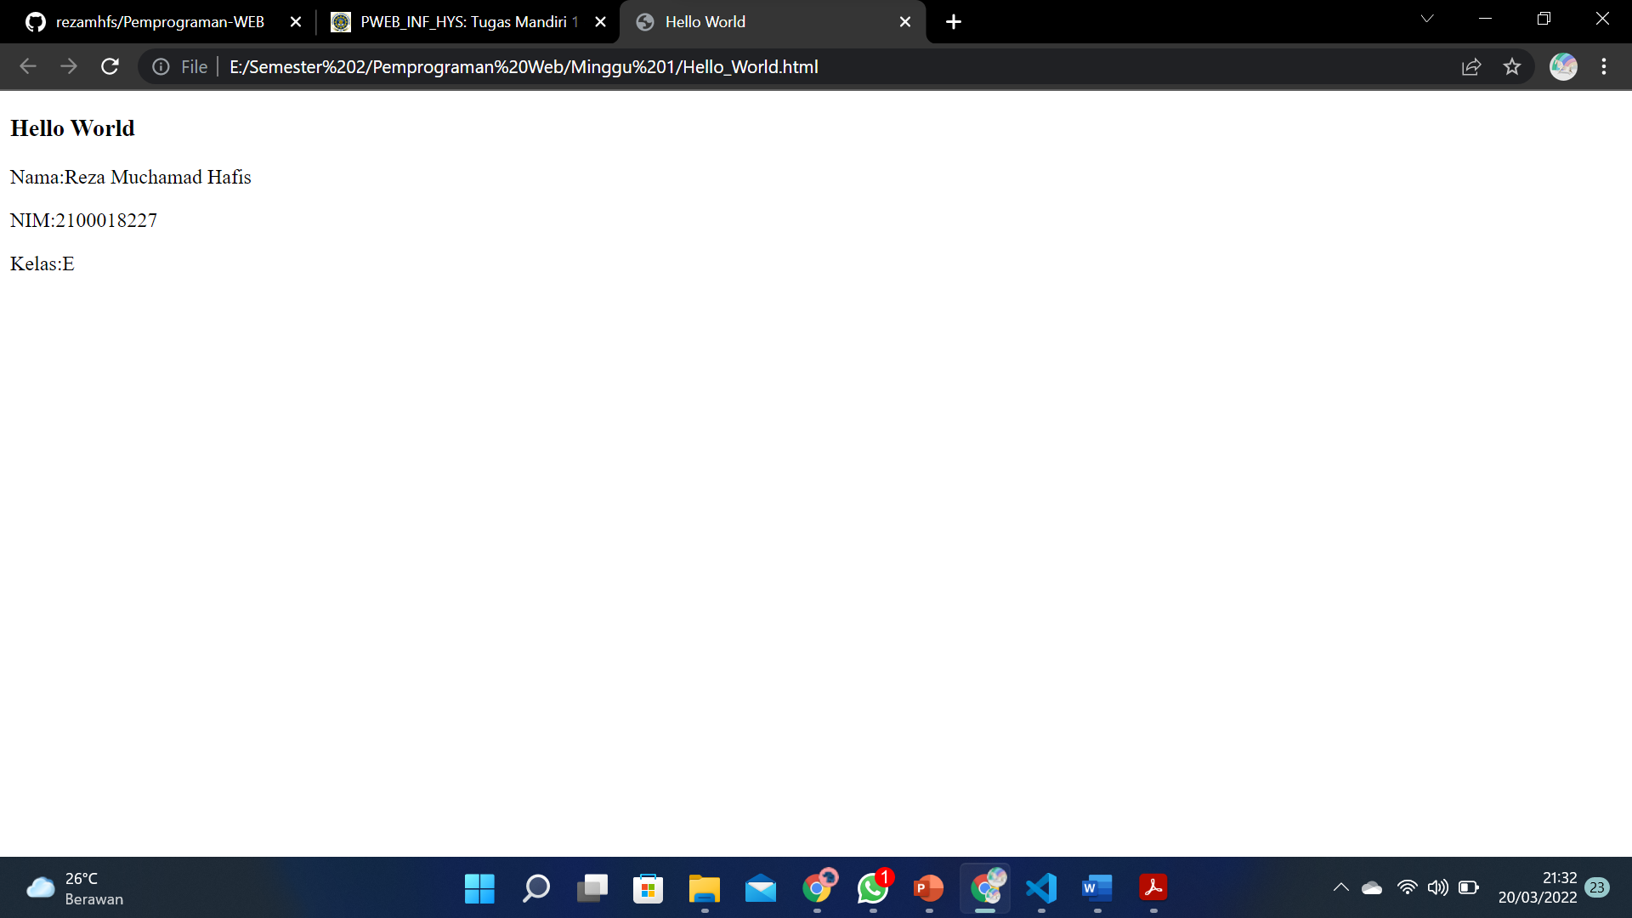

**Link Github** : <https://github.com/rezamhfs/Pemprograman-WEB>